**Reverse Mentoring**

**@ NCHA**

**Mentor’s Personal Reflections Journal**

**The Purpose of This Journal**

This is your personal reflection journal as part of our Reverse Mentoring programme. It is intended as a reflective practice to assist with your learning as you host and experience your first reverse mentoring relationship.

There is no expectation that you will be required to share any of the contents. This is a space to note down your reflections about what rises in your awareness following each mentoring conversation. This may be new challenging thoughts and insights, positive experiences you encounter, as well as points for consideration in how the programme could be improved for future mentoring groups.

We do intend to evaluate your experience of the programme at the end of this first phase. This will be via a separate process from this journal document. However, by using this journal and capturing your reflections as you go, this may assist you later when invited to share your feedback on the programme.

In this journal there are some reminders from the training about core skills, and a checklist for making your ‘mentoring agreement’ with your mentee.

There is also space for you to capture reflections for:

* Personal reflections following each mentoring conversation
* Mentors Final Review to summarise your overall experience and insights
* The ‘Organisational Feedback’ section allows you to capture any points you think NCHA could learn from to help us improve our inclusive organisational culture.

**Core Mentoring Skills**

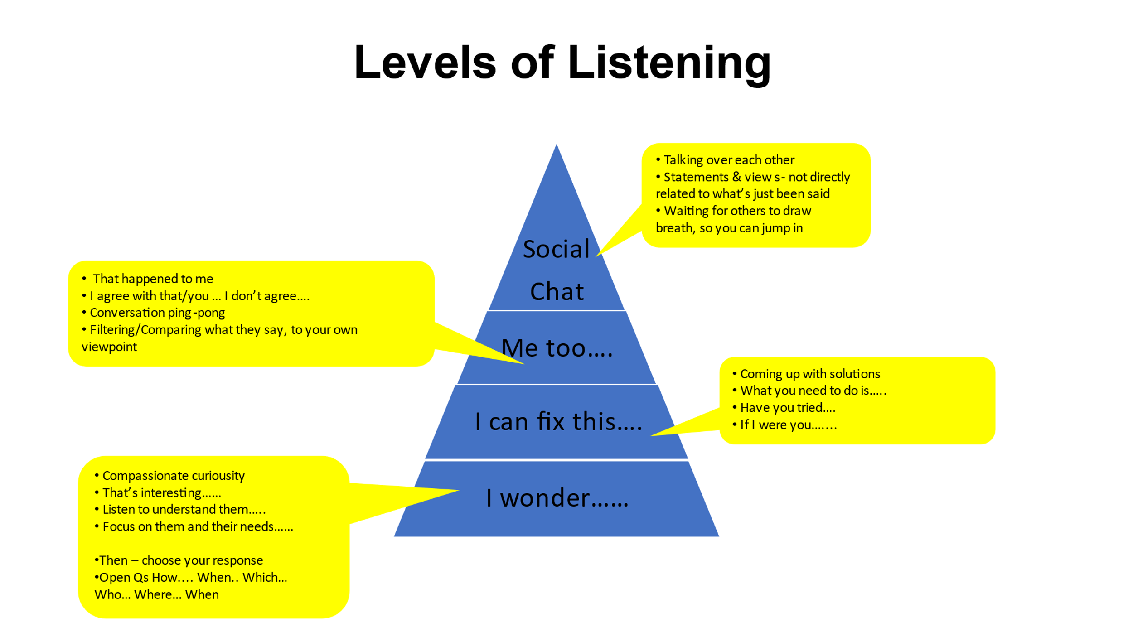

**Open Questions**

**WHEN?**

**WHAT?**

**WHICH?**

**WHO?**

**WHY?**

**HOW?**

**WHERE?**

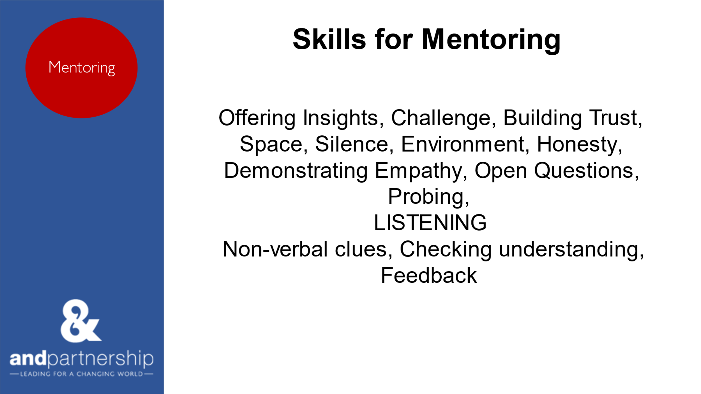

**Mentoring Practise Conversations**

* How might you start the first mentor conversation?
* What questions might you ask?
* How will you tell your story?
* How could you sense check what your mentee has ‘received’ from your story?

**Mentoring Agreement Conversation**



**Mentor’s Reflection Journal: Conversation 1**

What did I notice, observations or insights did I gain from today?

How did I feel before, during and after the discussion? What challenged my thinking, did I notice any feelings of discomfort?

What do I want to explore next time?

Are there any points or questions I want to explore at my next supervision session?

**Mentor’s Reflection Journal: Session 2**

What were the insights which you gained from this session?

Where there any aspects of the discussion which challenged your thinking, or did you notice any feelings of discomfort?

Are there any points or questions you would like to raise at your future supervision session?

**Mentor’s Reflection Journal: Session 3**

What were the insights which you gained from this session?

Where there any aspects of the discussion which challenged your thinking, or did you notice any feelings of discomfort?

Are there any points or questions you would like to raise at your future supervision session?

**Mentor’s Reflection Journal: Session 4**

What were the insights which you gained from this session?

Where there any aspects of the discussion which challenged your thinking, or did you notice any feelings of discomfort?

Are there any points or questions you would like to raise at your future supervision session?

**Mentor’s Reflection Journal: Session 5**

What were the insights which you gained from this session?

Where there any aspects of the discussion which challenged your thinking, or did you notice any feelings of discomfort?

Are there any points or questions you would like to raise at your future supervision session?

**Mentor’s Reflection Journal: Session 6**

What were the insights which you gained from this session?

Where there any aspects of the discussion which challenged your thinking, or did you notice any feelings of discomfort?

Are there any points or questions you would like to raise at your future supervision session?

**Mentor’s Final Review**

What were the key points you feel you were able to communicate about your lived experience during this process?

What have you discovered about yourself during this process?

In one sentence, how would you summarise what you have personally gained from this reverse mentoring experience?

**Organisational Feedback: Mentor’s Notes**

To support further improvement in inclusion at NCHA, my feedback and recommendations from my own experience and learning as a Mentor are…